Geometry: Unit 10, Lesson 1
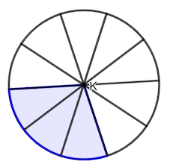
- Circle $K$ is shown, where the gray shading represents a sector formed. What fraction of the circle is represented by the shaded region?

$$\frac{3}{10}$$

- What is the product of $\frac{3}{8}⋅360$?

$$135$$

- What is an expression that represents the area of $\frac{1}{4}$ of a circle with a radius of $8$?

$$A=\frac{1}{4}⋅π⋅8^{2}$$

